Dear Medicaid Beneficiary:

Arkansas Medicaid has created two new ways to help you keep track of your doctors, health care providers, and medical records all in one secure place.

Starting on June 30, 2021, you can go to https://mdp.mmis.arkansas.gov/ or download the MyARMedicaid app available through the Apple or Google App stores on your smart phone. From there you can create an account and log in to see:
- claims that Medicaid has paid for you
- doctors or providers you have seen
- medical visits or procedures you have had
- your prescriptions and immunization records

With your permission, your health care providers also will be able to see your records, which will give them a more complete view of your health and a better way to support you as a patient.


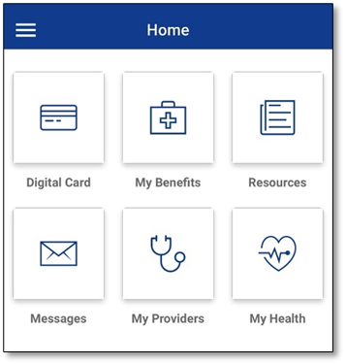
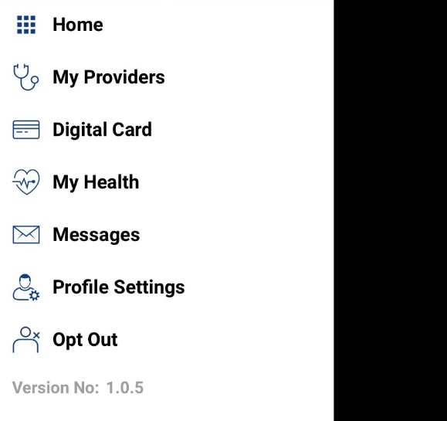

How does Arkansas Medicaid protect your information?

When you give your information to Arkansas Medicaid, your information is protected by a federal law called the Health Insurance Portability and Accountability Act (HIPAA). MyARMedicaid – the only app sponsored by Arkansas Medicaid – is a safe, secure, and easy way to view your Medicaid information. This app will not sell or share your information to advertisers or researchers, and your information will be protected by HIPAA.

How do other non-State sponsored apps protect your information?

You do not have to choose MyARMedicaid to view your health care information, but most non-State-sponsored apps will not be covered by HIPAA. Instead your information would be protected by the Federal Trade Commission (FTC), which simply protects against deceptive acts such as if an app shares personal data without permission when its privacy policy says it will not
How can you protect your information?

If you choose an app other than MyARMedicaid, be sure to do these things to protect your information:

- Look for an easy-to-read privacy policy that clearly explains how the app will use your data. If an app does not have a privacy policy, you should not use it.
  - What health information will the app collect? Will this app record other non-health data from your cell phone or mobile device, such as your location?
  - Will the app store your data without your name or other identifying information?
  - How will the app use your information?

- Find out if the app will sell or share your data to third parties for any reason, such as advertising or research.
  - Can you limit the app’s use and disclosure of your information?
  - What security measures does the app use to protect your information?
  - How can you correct inaccurate information in the app?

- Check if the app has a process for collecting and responding to user complaints.
  - What is the app’s policy is for deleting your information once you terminate access?
  - Do you have to do more than just delete the app from your device to stop the app from getting your information?
Where can you get help if you have questions?

Learn more about your rights as a patient under HIPAA and who is obligated to follow HIPAA here: https://www.hhs.gov/hipaa/for-individuals/guidance-materials-forconsumers/index.html.
Understand the FTC’s policies about mobile app privacy and security for consumers here: https://www.consumer.ftc.gov/articles/0018-understanding-mobile-apps

If you have questions about our new website or MyARMedicaid, please contact myarkansasmedicaid_hd@gainwelltechnologies.com.

