|  |  |
| --- | --- |
| section II - Podiatrist  Contents |  |

200.000 Podiatrist GENERAL INFORMATION

201.000 Arkansas Medicaid Participation Requirements for Podiatrists

201.001 Electronic Signatures

201.100 Participation Requirements for Individual Podiatrists

201.200 Group Providers of Podiatrists’ Services

201.300 Podiatrists in Arkansas and Bordering States

201.400 Podiatrists in States Not Bordering Arkansas

201.600 Podiatrist’s Role in the Pharmacy Program

201.601 Tamper Resistant Prescription Applications

202.000 Medicare Mandatory Assignment of Claims for Physician’s Services

203.000 Documentation Requirements

204.000 Role in the Child Health Services (EPSDT) Program

205.000 Clinical Laboratory Improvement Amendments (CLIA) Implementation

210.000 PROGRAM COVERAGE

211.000 Introduction

212.000 Scope

212.100 Assistant Surgeon

213.000 Reserved

213.100 Reserved

213.200 Reserved

214.000 Benefit Limits

214.100 New Patient Visit

214.200 Medical Visits and Surgical Services

214.300 Diagnostic Laboratory and Radiology/Other Services

215.000 Extension of Benefits

215.100 Procedure for Obtaining Extension of Benefits for Podiatry Services

215.110 Documentation Requirements

215.115 Extension of Benefits Review Process

215.120 Administrative Reconsideration and Appeals

215.130 Reserved

220.000 PRIOR AUTHORIZATION

221.000 Prior Authorization

221.100 Procedure for Requesting Prior Authorization

221.200 Approvals and Denials of Prior Authorization Requests

221.300 Post-Authorization

230.000 REIMBURSEMENT

231.000 Rate Appeal Process

231.010 Fee Schedules

240.000 Billing Procedures

241.000 Introduction to Billing

242.000 CMS-1500 Billing Procedures

242.100 Procedure Codes

242.110 Procedure Codes Payable in a Nursing Care Facility

242.120 Procedure Codes Requiring Prior Authorization

242.130 Procedure Codes Payable for Laboratory and X-Ray Services

242.200 Podiatrist National Place of Service Codes

242.210 National Place of Service Codes

242.300 Billing Instructions—Paper Only

242.310 Completion of CMS-1500 Claim Form

242.400 Special Billing Procedures

242.410 Completion of Forms for Medicare/Medicaid Deductible and Coinsurance

242.420 Services Prior to Medicare Entitlement

242.430 Services Not Medicare Approved

242.440 Reserved

242.450 National Drug Codes (NDCs)

|  |  |
| --- | --- |
| 200.000 Podiatrist GENERAL INFORMATION |  |
| 201.000 Arkansas Medicaid Participation Requirements for Podiatrists |  |
| 201.001 Electronic Signatures | 10-8-10 |

Medicaid will accept electronic signatures provided the electronic signatures comply with Arkansas Code § 25-31-103 et seq.

|  |  |
| --- | --- |
| 201.100 Participation Requirements for Individual Podiatrists | 7-15-11 |

Podiatrists must meet the Provider Participation and enrollment requirements contained within Section 140.000 of this manual as well as the following criteria to be eligible to participate in the Arkansas Medicaid Program:

A. A provider must be licensed to practice podiatry services in his or her state.

B. A copy of the current state license must accompany the provider application packet.

C. In order for Arkansas Medicaid to pay for services provided to an Arkansas Medicaid beneficiary who is dually eligible for Medicare and Medicaid, and is provided services that are not covered by both Medicare and Medicaid, the provider must first bill Medicare. The Omnibus Budget Reconciliation Act of 1989 requires the mandatory assignment of Medicare claims for services provided by podiatrists. Podiatrists must submit their Medicare provider number to Arkansas Medicaid to ensure the Medicare claims will electronically cross over. To enroll and accept assignment in the Title XVIII – Medicare Program, see Section 202.000.

D. The provider must submit Clinical Laboratory Improvement Amendments (CLIA) certification, if applicable. (Section 205.000 contains information regarding CLIA certification.)

|  |  |
| --- | --- |
| 201.200 Group Providers of Podiatrists’ Services | 10-15-09 |

Group providers of podiatric services must meet the following criteria in order to be eligible for participation in the Arkansas Medicaid Program.

If a podiatrist is a member of a group, each individual podiatrist and the group must both enroll according to the following criteria:

A. Each individual podiatrist within the group must enroll following the criteria established in Section 201.100.

B. All group providers are “pay to” providers only. The service must be performed and billed by a Medicaid-enrolled licensed podiatrist with the group.

|  |  |
| --- | --- |
| 201.300 Podiatrists in Arkansas and Bordering States | 12-15-14 |

Podiatrists in Arkansas and the six bordering states (Louisiana, Mississippi, Missouri, Oklahoma, Tennessee and Texas) may be enrolled as routine services providers if they meet all Arkansas Medicaid participation requirements outlined in Section 201.100.

Routine Services Providers

A. Routine services providers may be enrolled in the program as providers of routine services.

B. Reimbursement may be available for all podiatrist services covered in the Arkansas Medicaid Program.

C. Claims must be filed according to Section II of this manual. This includes assignment of ICD and HCPCS codes for all services rendered.

|  |  |
| --- | --- |
| 201.400 Podiatrists in States Not Bordering Arkansas | 3-1-11 |

A. Providers in states not bordering Arkansas may enroll in the Arkansas Medicaid program as limited services providers only after they have provided services to an Arkansas Medicaid eligible beneficiary and have a claim or claims to file with Arkansas Medicaid.

To enroll, a non-bordering state provider must download an Arkansas Medicaid application and contract from the Arkansas Medicaid website and submit the application, contract and claim to Arkansas Medicaid Provider Enrollment. A provider number will be assigned upon approval of the provider application and the Medicaid contract. [View or print the provider enrollment and contract package (Application Packet ).](https://humanservices.arkansas.gov/wp-content/uploads/ApplicationPacket.pdf) [View or print Medicaid Provider Enrollment Unit contact information.](https://humanservices.arkansas.gov/wp-content/uploads/ProviderEnrol.docx)

B. Limited services providers remain enrolled for one year.

1. If a limited services provider provides services to another Arkansas Medicaid beneficiary during the year of enrollment and bills Medicaid, the enrollment may continue for one year past the most recent claim’s last date of service, if the enrollment file is kept current.

2. During the enrollment period, the provider may file any subsequent claims directly to the Medicaid fiscal agent.

3. Limited services providers are strongly encouraged to file subsequent claims through the Arkansas Medicaid website because the front-end processing of web-based claims ensures prompt adjudication and facilitates reimbursement.

|  |  |
| --- | --- |
| 201.600 Podiatrist’s Role in the Pharmacy Program | 8-1-21 |

**PRESCRIPTION DRUG INFORMATION**

Medicaid covers prescription drugs in accordance with policies and regulations set forth in this section and pursuant to orders (prescriptions) from authorized prescribers in relation to their specialty of practice. The Arkansas Medicaid Program complies with the Medicaid Prudent Pharmaceutical Purchasing Program (MPPPP) that was enacted as part of the Omnibus Budget Reconciliation Act (OBRA) of 1990. **This law requires Medicaid to limit coverage to drugs manufactured by pharmaceutical companies that have signed rebate agreements.** A numeric listing of approved pharmaceutical companies and their respective labeler codes is located on the DHS or designated pharmacy vendor website. [View or print numeric listing of approved pharmaceutical companies and their respective labeler codes.](https://ar.primetherapeutics.com/provider-documents) Except for drugs in the categories excluded from coverage, Arkansas Medicaid covers all drug products manufactured by companies with listed labeler codes.

The latest information regarding prescription drug coverage is available from DHS or its designated Medicaid Pharmacy vendor. [View or print contact information for the DHS contracted Pharmacy Vendor](https://humanservices.arkansas.gov/wp-content/uploads/Pharmacy.docx).

|  |  |
| --- | --- |
| 201.601 Tamper Resistant Prescription Applications | 2-6-17 |

Section 7002(b), which amends section 1903(i) of the Social Security Act (the Act) (42 U.S.C. section 1936b(i)) by adding new paragraph (23), states that payment shall not be made for “. . . amounts expended for medical assistance for covered outpatient drugs (as defined in section 1927(k)(2) for which the prescription was executed in written (and non-electronic) form unless the prescription was executed on a tamper-resistant pad.” This provision becomes effective on October 1, 2007. The tamper-resistant pad requirement of section 7002(b) applies to all outpatient drugs, including over-the-counter drugs in States that reimburse for prescriptions for such items. Section 1927(k)(3) of the Act provides exceptions to section 1927(k)(2) for drugs provided in nursing facilities, intermediate care facilities for individuals with intellectual disabilities, and other specified institutional and clinical settings. Such drugs in these settings (to the extent that they are not separately reimbursed) are exceptions to section 1927(k)(2), and, therefore, are not subject to the tamper-resistant pad requirement of section 7002(b). Section 7002(b) is applicable regardless of whether Medicaid is the primary or secondary payer of the prescription being filled.

See the CMS website for technical information:

<https://www.cms.gov/Medicare-Medicaid-Coordination/Fraud-Prevention/FraudAbuseforProfs/TRP.html>

Regardless of whether Medicaid is the primary or secondary payer of the prescription being filled, this rule applies to all non-electronic Medicaid-covered outpatient drugs except:

1. Emergency fills of non-controlled or controlled dangerous substances for which a prescriber provides the pharmacy with a verbal, faxed, electronic or compliant written prescription within 72 hours after the date on which the prescription was filled;

2. Drugs provided in nursing facilities, intermediate care facilities for individuals with intellectual disabilities and other federally-specified institutional and clinical settings so long as those drugs are not billed separately to Medicaid, for example, those billed by an individual pharmacy provider.

For purposes of this rule, “electronic prescriptions” include e-prescriptions transmitted to the pharmacy, prescriptions faxed to the pharmacy or prescriptions communicated to the pharmacy by telephone by a prescriber.

|  |  |
| --- | --- |
| 202.000 Medicare Mandatory Assignment of Claims for Physician’s Services | 10-15-09 |

See Section 142.700 for detailed information regarding Medicare participation and Sections 332.000 through 332.300 for detailed information regarding Medicare-Medicaid Crossover Claim procedures.

NOTE: The podiatrist provider must notify the Provider Enrollment Unit of a Medicare identification number. [**View or print Provider Enrollment Unit contact information.**](https://humanservices.arkansas.gov/wp-content/uploads/ProviderEnrol.docx)

|  |  |
| --- | --- |
| 203.000 Documentation Requirements | 10-15-09 |

Documentation and provider participation requirements are detailed within Section 140.000, Provider Participation, of this manual. Documentation should consist of, at a minimum, material that includes:

A. History and physical examination.

B. Chief complaint on each visit.

C. Tests and results.

D. Diagnosis.

E. Treatment including prescriptions.

F. Signature or initials of podiatrist after each visit.

G. Copies of office, clinic, hospital and/or emergency room records that are available to disclose services.

H. Each record must reflect date of visit when services were provided.

|  |  |
| --- | --- |
| 204.000 Role in the Child Health Services (EPSDT) Program | 10-13-03 |

The Child Health Services (EPSDT) Program is a federally mandated child health component of Medicaid. It is designed to bring comprehensive health care to individuals eligible for medical assistance from birth up to their 21st birthday. The purpose of this program is to detect and treat health problems in the early stages and to provide preventive health care, including necessary immunizations. Child Health Services (EPSDT) combines case management and support services with screening, diagnostic and treatment services delivered on a periodic basis.

If a condition is diagnosed through a Child Health Services (EPSDT) screen that requires treatment services not normally covered under the Arkansas Medicaid Program, those treatment services will also be considered for reimbursement if the service is medically necessary and permitted under federal Medicaid regulations.

For more information regarding the EPSDT program, providers may view the Child Health Services (EPSDT) Manual.

|  |  |
| --- | --- |
| 205.000 Clinical Laboratory Improvement Amendments (CLIA) Implementation | 10-13-03 |

Medicaid implemented the Clinical Laboratory Improvement Amendments (CLIA) to edit claims for:

A. Laboratories that do not have a CLIA certificate,

B. Laboratories submitting claims for services not covered by their CLIA certificate and

C. Laboratories submitting claims for services rendered outside the effective dates of the CLIA certificate.

There are no special billing requirements related to the CLIA implementation. The claims processing system will edit laboratory procedure codes against the billing provider’s Medicaid enrollment file. Claims will be edited in accordance with the criteria listed in A, B and C above. If these requirements are not met, claims will automatically deny.

|  |  |
| --- | --- |
| 210.000 PROGRAM COVERAGE |  |
| 211.000 Introduction | 10-1-08 |

A. The Arkansas Medicaid Program reimburses enrolled providers for the program covered medical care of eligible Medicaid beneficiaries.

B. Medicaid reimbursement is conditional upon providers’ compliance with program policy as stated in provider manuals, manual update transmittals and official program correspondence.

C. All Medicaid benefits are based on medical necessity. Refer to the Glossary for a definition of medical necessity. [View or print the Glossary.](https://humanservices.arkansas.gov/wp-content/uploads/Section_IV.docx)

1. Service coverage will be denied and reimbursement recouped if a service is not medically necessary.

2. The finding of medical necessity may be made by any of the following:

a. Medical Director for the Medicaid Program

b. Quality Improvement Organization (QIO)

c. Peer Review Committee for the Medicaid Program

|  |  |
| --- | --- |
| 212.000 Scope | 2-1-22 |

A. The Arkansas Medicaid Program covers podiatrist services through 42 Code of Federal Regulations, Section 440.60.

B. Arkansas Medicaid covers podiatrist services for eligible Medicaid beneficiaries of all ages.

C. Podiatrist services require a primary care physician (PCP) referral.

D. Podiatrist services include, but are not limited to, office and outpatient services, home visits, office and inpatient consultations, laboratory and X-ray services, physical therapy and surgical services. Section 242.100 contains the full list of procedure codes applicable to podiatry services.

E. Many podiatrist services covered by the Arkansas Medicaid Program are restricted or limited.

1. Section 214.000 describes the benefit limits on the quantity of covered services clients may receive.

2. Section 220.000 describes prior-authorization requirements for certain services.

|  |  |
| --- | --- |
| 212.100 Assistant Surgeon | 1-1-05 |

The Arkansas Medicaid Program does not cover assistant surgeon services in the podiatry program.

|  |  |
| --- | --- |
| 213.000 Reserved | 3-15-14 |
| 213.100 Reserved | 3-15-14 |
| 213.200 Reserved | 3-15-14 |
| 214.000 Benefit Limits | 8-1-21 |

Medicaid-eligible patients are responsible for payment for services beyond the established benefit limits, unless DHS or its designated vendor authorizes an extension of a particular benefit. If a Medicaid-eligible patient elects to receive a service for which a benefit extension has been denied or is subsequently denied, the patient is responsible for payment. [View or print contact information to obtain the DHS or designated vendor step-by-step process for requesting extension of benefits.](https://humanservices.arkansas.gov/wp-content/uploads/AFMC.docx)

|  |  |
| --- | --- |
| 214.100 New Patient Visit | 10-1-08 |

Providers are allowed to bill one new patient visit procedure code per beneficiary, per attending provider in a three (3) year period.

|  |  |
| --- | --- |
| 214.200 Medical Visits and Surgical Services | 10-1-08 |

The Arkansas Medicaid Program covers two medical visits per state fiscal year (July 1 through June 30) for medical services provided by a podiatrist in an office, a beneficiary’s home or in a nursing facility for eligible beneficiaries age 21 and over. Benefit extensions may be granted in cases of documented medical necessity.

Medical visits for individuals under the age of 21 in the Child Health Services (EPSDT) Program do not have a benefit limit.

Surgical services provided by a podiatrist are not included in the two visits per state fiscal year (SFY) benefit limit for individuals age 21 and over.

|  |  |
| --- | --- |
| 214.300 Diagnostic Laboratory and Radiology/Other Services | 7-1-22 |

A. Diagnostic laboratory services and radiology/other services provided by a podiatrist will be included in the benefit limits for outpatient diagnostic laboratory services and outpatient radiology/other services for individuals twenty-one (21) years of age and over.

1. Diagnostic laboratory services benefits are limited to five hundred dollars ($500) per State Fiscal Year (SFY: July 1 through June 30), and radiology/other services benefits are limited to five hundred dollars ($500) per SFY.

2 Radiology/other services include without limitation diagnostic X-rays, ultrasounds, and electronic monitoring/machine tests, such as electrocardiograms (ECG or EKG).

3. Diagnostic laboratory services and radiology/other services defined as Essential Health Benefits by the U.S. Preventive Services Task Force (USPSTF) are exempt from counting toward either of the two new annual caps.

[View or print the essential health benefit procedure codes.](https://humanservices.arkansas.gov/wp-content/uploads/EsstlHlthBenefitProcCodes.docx)

B. There are no benefits limit for individuals under twenty-one (21) years of age, except for the limitations on fetal echography (ultrasound) and fetal non-stress tests.

C. Benefit extensions may be granted in cases of documented medical necessity.

D. Section 242.130 contains procedure codes payable for diagnostic laboratory and radiology/other services.

|  |  |
| --- | --- |
| 215.000 Extension of Benefits | 7-1-22 |

Benefit extensions may be requested in the following situations:

A. Extension of Benefits for Medical Visits;

1. Extensions of benefits may be requested for medical visits that exceed the two (2) visits per State Fiscal Year (SFY: July 1 through June 30) for individuals twenty-one (21) years of age and over with documented medical necessity provided along with the request.

B. Extension of Benefits for Diagnostic Laboratory and Radiology/Other Services;

1. Diagnostic laboratory services benefits are limited to five hundred dollars ($500) per State Fiscal Year (SFY: July 1 through June 30), and radiology/other services benefits are limited to five hundred dollars ($500) per SFY.

2. Radiology/other services include without limitation diagnostic X-rays, ultrasounds, and electronic monitoring/machine tests, such as electrocardiograms (ECG or EKG).

3. Diagnostic laboratory services and radiology/other services defined as Essential Health Benefits by the U.S. Preventive Services Task Force (USPSTF) are exempt from counting toward either of the two new annual caps.

[View or print the essential health benefit procedure codes.](https://humanservices.arkansas.gov/wp-content/uploads/EsstlHlthBenefitProcCodes.docx)

4. Extension of the benefits limit for diagnostic laboratory and radiology/other services may be granted for individuals twenty-one (21) years of age and over when documented to be medically necessary.

C. The Arkansas Medicaid Program exempts the following diagnoses from the extension of benefit requirements when the diagnosis is entered as the primary diagnosis:

1. Malignant Neoplasm [[(View ICD codes)](https://humanservices.arkansas.gov/wp-content/uploads/PODIATR_215.000_list_1.xls)](https://humanservices.arkansas.gov/wp-content/uploads/PODIATR_215.000_list_1.xls);

2. HIV Infection, including AIDS [(View ICD codes)](https://humanservices.arkansas.gov/wp-content/uploads/PODIATR_215.000_list_2.xls);

3. Renal failure [(View ICD codes)](https://humanservices.arkansas.gov/wp-content/uploads/PODIATR_215.000_list_3.xls);

4. Pregnancy ([View ICD Codes](https://humanservices.arkansas.gov/wp-content/uploads/PHYSICN_225.100_list_4.xls)); and

5. Opioid Use Disorder (OUD) when treated with Medication Assisted Treatment (MAT). ([View ICD OUD Codes](https://humanservices.arkansas.gov/wp-content/uploads/MAT_ICD-10_ProcCodes.docx)) Designated diagnostic laboratory tests will be exempt from the diagnostic laboratory services benefit limit when the diagnosis is OUD. ([View Laboratory and Screening Codes](https://humanservices.arkansas.gov/wp-content/uploads/PHYSICN_LabCodes.docx)).

|  |  |
| --- | --- |
| 215.100 Procedure for Obtaining Extension of Benefits for Podiatry Services | 8-1-21 |

A. Requests for extension of benefits for podiatry services for beneficiaries over age 21 must be submitted to DHS or its designated vendor A request for extension of benefits must meet the medical necessity requirement, and adequate documentation must be provided to support this request.

1. Requests for extension of benefits are considered only after a claim is denied because a benefit is exhausted/exceeds benefit limit.

2. The request for extension of benefits must be received within ninety (90) calendar days of the date of the benefits-exhausted denial. The count begins on the next working day after the date of the Remittance and Status Report (RA) on which the benefits-exhausted denial appears.

3. Submit a copy of the Medical Assistance Remittance and Status Report reflecting the claim’s denial for exhausted benefits with the request. Do not send a claim.

B. Use form DMS-671, Request for Extension of Benefits for Clinical, Outpatient, Laboratory and X-Ray Services, to request extension of benefits for podiatry services. [View or print form DMS-671.](https://humanservices.arkansas.gov/wp-content/uploads/DMS-671.docx) Consideration of requests for extension of benefits requires correct completion of all fields on this form. The instructions for completion of this form are located on the back of the form. The provider’s signature (with his or her credentials) and the date of the request are required on the form. Stamped or electronic signatures are accepted. All applicable records that support the medical necessity of the extended benefits request should be attached.

C. An extension of benefits request will be approved, denied, or pended to ask for additional information within thirty (30) calendar days of receipt of the request. Reviewers will simultaneously advise the provider and the beneficiary when a request is denied.

|  |  |
| --- | --- |
| 215.110 Documentation Requirements | 5-1-06 |

A. To request extension of benefits for any benefit limited service, all applicable records that support the medical necessity of extended benefits are required.

B. Documentation requirements are as follows.

1. Clinical records must:

a. Be legible and include records supporting the specific request

b. Be signed by the performing provider

c. Include clinical, outpatient and/or emergency room records for dates of service in chronological order

d. Include related diabetic and blood pressure flow sheets

e. Include current medication list for date of service

f. Include obstetrical record related to current pregnancy

g. Include clinical indication for laboratory and x-ray services ordered with a copy of orders for laboratory and x-ray services signed by the physician

2. Laboratory and radiology reports must include:

a. Clinical indication for laboratory and x-ray services ordered

b. Signed orders for laboratory and radiology services

c. Results signed by performing provider

d. Current and all previous ultrasound reports, including biophysical profiles and fetal non-stress tests

|  |  |
| --- | --- |
| 215.115 Extension of Benefits Review Process | 8-1-21 |

[View or print contact information to obtain the DHS or designated vendor step-by-step process for extension of benefits review.](https://humanservices.arkansas.gov/wp-content/uploads/AFMC.docx)

|  |  |
| --- | --- |
| 215.120 Administrative Reconsideration and Appeals | 6-1-25 |

A. Medicaid allows only one (1) reconsideration of an adverse decision. Reconsideration requests must be submitted in accordance with Section 160.000 of Section I of this Manual.

B. When the state Medicaid agency or its designee denies a reconsideration request or issues any adverse decision, the beneficiary may appeal and request a fair hearing. A request for a fair hearing must be submitted in accordance with Sections 160.000, 190.000, and 191.000 of Section I of this Manual.

|  |  |
| --- | --- |
| 215.130 Reserved | 6-1-25 |

|  |  |
| --- | --- |
| 220.000 PRIOR AUTHORIZATION |  |

There are certain surgical procedures and medical services and procedures that are not reimbursable without prior authorization, either because of federal requirements or because of the nature of the service.

DHS or its designated vendor performs prior authorizations for several medical or surgical procedures. Certain procedures are restricted to the outpatient setting unless prior authorized for inpatient services. Other services may only be billed when performed in a nursing home or skilled nursing facility setting. [View or print contact information to obtain the DHS or designated vendor step-by-step process for requesting prior authorization.](https://humanservices.arkansas.gov/wp-content/uploads/afmc.docx)

Section 242.120 contains the list of all procedure codes that require prior authorization.

|  |  |
| --- | --- |
| 221.000 Prior Authorization | 8-1-21 |

Prior authorization determinations are made by utilizing established medical or administrative criteria combined with the professional judgment of physician advisors. Payment of services is made to participating providers in accordance with federal regulations.

|  |  |
| --- | --- |
| 221.100 Procedure for Requesting Prior Authorization | 8-1-21 |

It is the responsibility of the podiatrist to initiate the prior authorization request. [View or print contact information to obtain the DHS or designated vendor step-by-step process for requesting prior authorization.](https://humanservices.arkansas.gov/wp-content/uploads/AFMC.docx)

CPT codes that require prior authorization are located in Section 242.120 of this manual.

|  |  |
| --- | --- |
| 221.200 Approvals and Denials of Prior Authorization Requests | 8-1-21 |

A. If approved, a prior authorization control number will be assigned.

B. If surgery is involved, a copy of the prior authorization will be sent to the hospital where the service will be performed. If the hospital has not received a copy of the authorization before the time of admission, the hospital will contact the admitting podiatrist to verify that prior authorization has been granted.

It is the responsibility of the primary podiatrist to distribute a copy of the authorization to the anesthesiologist and the assistant podiatrist if the assistant has been requested and approved.

C. The prior authorization control number must be entered in the appropriate field in the CMS-1500 claim format when billing for the procedure. The Medicaid Program will not pay for inpatient hospital services that require prior authorization if the prior authorization has not been requested and approved.

D. Consulting podiatrists must have a separate prior authorization and are responsible for obtaining the prior authorization for their procedures. They will be given a prior authorization at the time of their contact on those cases that are approved. A letter verifying the PA number will be sent to the consultant upon request.

Prior authorization of a service does not guarantee eligibility for a beneficiary. Payment is subject to verification that the beneficiary was eligible at the time the services were provided.

|  |  |
| --- | --- |
| 221.300 Post-Authorization | 8-1-21 |

Post-authorization will be granted only for emergency procedures or retroactively eligible beneficiaries. Requests for emergency procedures must be requested on the first working day after the procedure has been performed. In cases of retroactive eligibility, DHS or its designated vendor must be contacted for post-authorization within sixty (60) days of the authorization date. [View or print contact information to obtain the DHS or designated vendor step-by-step process for post-authorization.](https://humanservices.arkansas.gov/wp-content/uploads/AFMC.docx)

|  |  |
| --- | --- |
| 230.000 REIMBURSEMENT | 10-13-03 |

Reimbursement is based on the lesser of:

A. The amount billed or

B. The Title XIX (Medicaid) maximum.

|  |  |
| --- | --- |
| 231.000 Rate Appeal Process | 11-1-09 |

A provider may request reconsideration of a program decision by writing to the Assistant Director, Division of Medical Services. This request must be received within 20 calendar days following the application of policy and/or procedure or the notification of the provider of its rate. Upon receipt of the request for review, the Assistant Director will determine the need for a program/provider conference and will contact the provider to arrange a conference if needed. Regardless of the program decision, the provider will be afforded the opportunity for a conference, if he or she so wishes, for a full explanation of the factors involved and the program decision. Following review of the matter, the Assistant Director will notify the provider of the action to be taken by the Division within 20 calendar days of receipt of the request for review or the date of the program/provider conference.

When the provider disagrees with the decision made by the Assistant Director, Division of Medical Services, the provider may appeal the question to a standing rate review panel established by the Director of the Division of Medical Services. The rate review panel will include one member of the Division of Medical Services, a representative of the provider association and a member of the Department of Human Services (DHS) management staff, who will serve as chairperson.

The request for review by the rate review panel must be postmarked within 15 calendar days following the notification of the initial decision by the Assistant Director, Division of Medical Services. The rate review panel will meet to consider the question(s) within 15 calendar days after receipt of a request for such appeal. The question(s) will be heard by the panel and a recommendation will be submitted to the Director of the Division of Medical Services.

|  |  |
| --- | --- |
| 231.010 Fee Schedules | 12-1-12 |

Arkansas Medicaid provides fee schedules on the Arkansas Medicaid website. The fee schedule link is located at [https://medicaid.mmis.arkansas.gov/](https://humanservices.arkansas.gov/divisions-shared-services/medical-services/helpful-information-for-providers/fee-schedules/) under the provider manual section. The fees represent the fee-for-service reimbursement methodology.

Fee schedules do not address coverage limitations or special instructions applied by Arkansas Medicaid before final payment is determined.

Procedure codes and/or fee schedules do not guarantee payment, coverage or amount allowed. Information may be changed or updated at any time to correct a discrepancy and/or error. Arkansas Medicaid always reimburses the lesser of the amount billed or the Medicaid maximum.

|  |  |
| --- | --- |
| 240.000 Billing Procedures |  |
| 241.000 Introduction to Billing | 7-1-20 |

Podiatrist providers use the CMS-1500 form to bill the Arkansas Medicaid Program on paper for services provided to eligible Medicaid beneficiaries. Each claim may contain charges for only one (1) beneficiary.

Section III of this manual contains information about available options for electronic claim submission.

|  |  |  |
| --- | --- | --- |
| 242.000 CMS-1500 Billing Procedures | |  |
| 242.100 Procedure Codes | 2-1-22 | |

Sections 242.100 through 242.120 list the procedure codes payable to podiatrists. Any special billing or other requirements are described in parts A through F of this section and in Sections 242.110 and 242.120.

[View or print the procedure codes for Podiatrist services.](https://humanservices.arkansas.gov/wp-content/uploads/PODIATR_ProcCodes.xlsx)

A. Procedure codes for podiatry services provided in a nursing home or skilled nursing facility are listed in Section 242.110.

B. Procedure codes for podiatry services require prior authorization. To request prior authorization, providers must contact the Arkansas Foundation for Medical Care, Inc. (AFMC) (see Section 221.000 – 221.100).

C. Procedure codes payable to podiatrists for laboratory and X-ray services are located in Section 242.130.

D. Procedure code, Hospital Discharge Day Management, may not be billed by providers in conjunction with an initial or subsequent hospital care code (procedure codes). Initial hospital care codes and subsequent hospital care codes may not be billed on the day of discharge.

E. In addition to the CPT codes shown below are HCPCS codes and are payable to podiatrists. HCPCS code requires a paper claim. HCPCS codes must be billed with the manufacturer’s invoice.

F. Procedure code must be billed for a service provided in a beneficiary’s home.

The listed procedure codes and their descriptions are located in the *Physician’s Current Procedural Terminology (CPT)* book. Section III of the Podiatrist Manual contains information on how to purchase a copy of the CPT publication.

*Procedure codes are manually priced and require an operative report attached to a paper claim.

**Procedure codes require prior authorization. See Section 221.000 for detailed instructions.

|  |  |
| --- | --- |
| 242.110 Procedure Codes Payable in a Nursing Care Facility | 2-1-22 |

The following procedure codes may be billed when these services are provided in a nursing care facility.

[View or print the procedure codes for Podiatrist services.](https://humanservices.arkansas.gov/wp-content/uploads/PODIATR_ProcCodes.xlsx)

|  |  |
| --- | --- |
| 242.120 Procedure Codes Requiring Prior Authorization | 2-1-22 |

The following procedure codes require prior authorization before services may be provided.

[View or print the procedure codes for Podiatrist services.](https://humanservices.arkansas.gov/wp-content/uploads/PODIATR_ProcCodes.xlsx)

|  |  |
| --- | --- |
| 242.130 Procedure Codes Payable for Laboratory and X-Ray Services | 2-1-22 |

The following procedure codes may be billed for laboratory and X-ray services. Section 214.300 contains information regarding the $500.00 benefit limit for laboratory and X-ray services established for individuals age 21 and over.

[View or print the procedure codes for Podiatrist services.](https://humanservices.arkansas.gov/wp-content/uploads/PODIATR_ProcCodes.xlsx)

|  |  |  |
| --- | --- | --- |
| 242.200 Podiatrist National Place of Service Codes | |  |
| 242.210 National Place of Service Codes | 7-1-07 | | |

Electronic and paper claims require the same National Place of Service Code.

| **Place of Service** | **Place of Service Codes** |
| --- | --- |
| Inpatient Hospital | 21 |
| Outpatient Hospital | 22 |
| Emergency Room | 23 |
| Doctor’s Office | 11 |
| Patient’s Home | 12 |
| Nursing Facility | 32 |
| Skilled Nursing Facility | 31 |
| Other Locations | 99 |
| Ambulatory Surgical Center | 24 |
| Inpatient Psychiatric Facility | 51 |

|  |  |
| --- | --- |
| 242.300 Billing Instructions—Paper Only | 11-1-17 |

Bill Medicaid for professional services with form CMS-1500. The numbered items in the following instructions correspond to the numbered fields on the claim form. [View a sample form CMS-1500.](https://humanservices.arkansas.gov/wp-content/uploads/SampleCMS-1500.pdf)

Carefully follow these instructions to help the Arkansas Medicaid fiscal agent efficiently process claims. Accuracy, completeness, and clarity are essential. Claims cannot be processed if necessary information is omitted.

Forward completed claim forms to the Claims Department. [View or print the Claims Department contact information.](https://humanservices.arkansas.gov/wp-content/uploads/Claims.docx)

NOTE: A provider delivering services without verifying beneficiary eligibility for each date of service does so at the risk of not being reimbursed for the services.

|  |  |
| --- | --- |
| 242.310 Completion of CMS-1500 Claim Form | 2-1-22 |

| Field Name and Number | Instructions for Completion |
| --- | --- |
| 1. (type of coverage) | Not required. |
| 1a. INSURED’S I.D. NUMBER (For Program in Item 1) | Beneficiary’s or participant’s 10-digit Medicaid or ARKids First-A or ARKids First-B identification number. |
| 2. PATIENT’S NAME (Last Name, First Name, Middle Initial) | Beneficiary’s or participant’s last name and first name. |
| 3. PATIENT’S BIRTH DATE | Beneficiary’s or participant’s date of birth as given on the individual’s Medicaid or ARKids First-A or ARKids First-B identification card. Format: MM/DD/YY. |
| SEX | Check M for male or F for female. |
| 4. INSURED’S NAME (Last Name, First Name, Middle Initial) | Required if insurance affects this claim. Insured’s last name, first name, and middle initial. |
| 5. PATIENT’S ADDRESS (No., Street) | Optional. Beneficiary’s or participant’s completemailing address (street address or post office box). |
| CITY | Name of the city in which the beneficiary or participant resides. |
| STATE | Two-letter postal code for the state in which the beneficiary or participant resides. |
| ZIP CODE | Five-digit zip code; nine digits for post office box. |
| TELEPHONE (Include Area Code) | The beneficiary’s or participant’s telephone number or the number of a reliable message/contact/ emergency telephone. |
| 6. PATIENT RELATIONSHIP TO INSURED | If insurance affects this claim, check the box indicating the patient’s relationship to the insured. |
| 7. INSURED’S ADDRESS (No., Street) | Required if insured’s address is different from the patient’s address. |
| CITY |  |
| STATE |  |
| ZIP CODE |  |
| TELEPHONE (Include Area Code) |  |
| 8. RESERVED | Reserved for NUCC use. |
| 9. OTHER INSURED’S NAME (Last name, First Name, Middle Initial) | If patient has other insurance coverage as indicated in Field 11d, the other insured’s last name, first name, and middle initial. |
| a. OTHER INSURED’S POLICY OR GROUP NUMBER | Policy and/or group number of the insured individual. |
| b. RESERVED | Reserved for NUCC use. |
| SEX | Not required. |
| c. RESERVED | Reserved for NUCC use. |
| d. INSURANCE PLAN NAME OR PROGRAM NAME | Name of the insurance company. |
| 10. IS PATIENT’S CONDITION RELATED TO: |  |
| a. EMPLOYMENT? (Current or Previous) | Check YES or NO. |
| b. AUTO ACCIDENT? | Required when an auto accident is related to the services. Check YES or NO. |
| PLACE (State) | If 10b is YES, the two-letter postal abbreviation for the state in which the automobile accident took place. |
| c. OTHER ACCIDENT? | Required when an accident other than automobile is related to the services. Check YES or NO. |
| d. CLAIM CODES | The “Claim Codes” identify additional information about the beneficiary’s condition or the claim. When applicable, use the Claim code to report appropriate claim codes as designated by the NUCC. When required to provide the subset of Condition Codes, enter the condition code in this field. The subset of approved condition Codes is found at [www.nucc.org](http://www.nucc.org/) under Code Sets. |
| 11. INSURED’S POLICY GROUP OR FECA NUMBER | Not required when Medicaid is the only payer. |
| a. INSURED’S DATE OF BIRTH | Not required. |
| SEX | Not required. |
| b. OTHER CLAIM ID NUMBER | Not required. |
| c. INSURANCE PLAN NAME OR PROGRAM NAME | Not required. |
| d. IS THERE ANOTHER HEALTH BENEFIT PLAN? | When private or other insurance may or will cover any of the services, check YES and complete items 9, 9a and 9d. Only one box can be marked. |
| 12. PATIENT’S OR AUTHORIZED PERSON’S SIGNATURE | Enter “Signature on File,” “SOF” or legal signature. |
| 13. INSURED’S OR AUTHORIZED PERSON’S SIGNATURE | Enter “Signature on File,” “SOF” or legal signature. |
| 14. DATE OF CURRENT:  ILLNESS (First symptom) OR INJURY (Accident) OR PREGNANCY (LMP) | Required when services furnished are related to an accident, whether the accident is recent or in the past. Date of the accident.  Enter the qualifier to the right of the vertical dotted line. Use Qualifier 431 Onset of Current symptoms or Illness; 484 Last Menstrual Period. |
| 15. OTHER DATE | Enter another date related to the beneficiary’s condition or treatment. Enter the qualifier between the left-hand set of vertical dotted lines.  The “Other Date” identifies additional date information about the beneficiary’s condition or treatment. Use qualifiers:  454 Initial Treatment  304 Latest Visit or consultation  453 Acute Manifestation of a Chronic Condition  439 Accident  455 Last X-Ray  471 Prescription  090 Report Start (Assumed Care Date)  091 Report End (Relinquished Care Date)  444 First Visit or Consultation |
| 16. DATES PATIENT UNABLE TO WORK IN CURRENT OCCUPATION | Not required. |
| 17. NAME OF REFERRING PROVIDER OR OTHER SOURCE | Primary Care Physician (PCP) referral is required for Podiatrist Services. If services are the result of a Child Health Services (EPSDT) screening/ referral, enter the referral source, including name and title. |
| 17a. (blank) | Not required. |
| 17b. NPI | Enter NPI of the referring physician. |
| 18. HOSPITALIZATION DATES RELATED TO CURRENT SERVICES | When the serving/billing provider’s services charged on this claim are related to a beneficiary’s or participant’s inpatient hospitalization, enter the individual’s admission and discharge dates. Format: MM/DD/YY. |
| 19. ADDITIONAL CLAIM INFORMATION | Identifies additional information about the beneficiary’s condition or the claim. Enter the appropriate qualifiers describing the identifier. See [www.nucc.org](http://www.nucc.org/) for qualifiers. | |
| 20. OUTSIDE LAB? | Not required. |
| $ CHARGES | Not required. |
| 21. DIAGNOSIS OR NATURE OF ILLNESS OR INJURY | Enter the applicable ICD indicator to identify which version of ICD codes is being reported.  Use “9” for ICD-9-CM.  Use “0” for ICD-10-CM.  Enter indicator between the vertical, dotted lines in the upper right-hand portion of the field.  Diagnosis code for the primary medical condition for which services are being billed. Use the appropriate International Classification of Diseases (ICD). List no more than 12 diagnosis codes. Relate lines A-L to the lines of service in 24E by the letter of the line. Use the highest level of specificity. |
| 22. RESUBMISSION CODE | Reserved for future use. |
| ORIGINAL REF. NO. | Any data or other information listed in this field does not/will not adjust, void or otherwise modify any previous payment or denial of a claim. Claim payment adjustments, voids and refunds must follow previously established processes in policy. |
| 23. PRIOR AUTHORIZATION NUMBER | The prior authorization or benefit extension control number if applicable. |
| 24A. DATE(S) OF SERVICE | The “from” and “to” dates of service for each billed service. Format: MM/DD/YY.  1. On a single claim detail (one charge on one line), bill only for services provided within a single calendar month.  2. Providers may bill on the same claim detail for two or more sequential dates of service within the same calendar month when the provider furnished equal amounts of the service on each day of the date sequence. |
| B. PLACE OF SERVICE | Two-digit national standard place of service code. See Section 242.200 for codes. |
| C. EMG | Enter “Y” for “Yes” or leave blank if “No.” EMG identifies if the service was an emergency. |
| D. PROCEDURES, SERVICES, OR SUPPLIES |  |
| CPT/HCPCS | Enter the correct CPT or HCPCS procedure code from Sections 242.100 through 242.130. |
| MODIFIER | Not applicable to Podiatrist Services claims. |
| E. DIAGNOSIS POINTER | Enter the diagnosis code reference letter (pointer) as shown in Item Number 21 to relate to the date of service and the procedures performed to the primary diagnosis. When multiple services are performed, the primary reference letter for each service should be listed first; other applicable services should follow. The reference letter(s) should be A-L or multiple letters as applicable. The “Diagnosis Pointer” is the line letter from Item Number 21 that relates to the reason the service(s) was performed. |
| F. $ CHARGES | The full charge for the service(s) totaled in the detail. This charge must be the usual charge to any client, patient, or other beneficiary of the provider’s services. |
| G. DAYS OR UNITS | The units (in whole numbers) of service(s) provided during the period indicated in Field 24A of the detail. |
| H. EPSDT/Family Plan | Enter E if the services resulted from a Child Health Services (EPSDT) screening/referral. |
| I. ID QUAL | Not required. |
| J. RENDERING PROVIDER ID # | Enter the 9-digit Arkansas Medicaid provider ID number of the individual who furnished the services billed for in the detail or |
| NPI | Enter NPI of the individual who furnished the services billed for in the detail. |
| 25. FEDERAL TAX I.D. NUMBER | Not required. This information is carried in the provider’s Medicaid file. If it changes, please contact Provider Enrollment. |
| 26. PATIENT’S ACCOUNT NO. | Optional entry that may be used for accounting purposes; use up to 16 numeric or alphabetic characters. This number appears on the Remittance Advice as “MRN.” |
| 27. ACCEPT ASSIGNMENT? | Not required. Assignment is automatically accepted by the provider when billing Medicaid. |
| 28. TOTAL CHARGE | Total of Column 24F—the sum all charges on the claim. |
| 29. AMOUNT PAID | Enter the total of payments previously received on this claim. Do not include amounts previously paid by Medicaid. *Do **not** include in this total the automatically deducted Medicaid or ARKids First-B co-payments. |
| 30. RESERVED | Reserved for NUCC use. |
| 31. SIGNATURE OF PHYSICIAN OR SUPPLIER INCLUDING DEGREES OR CREDENTIALS | The provider or designated authorized individual must sign and date the claim certifying that the services were personally rendered by the provider or under the provider’s direction. “Provider’s signature” is defined as the provider’s actual signature, a rubber stamp of the provider’s signature, an automated signature, a typewritten signature, or the signature of an individual authorized by the provider rendering the service. The name of a clinic or group is not acceptable. |
| 32. SERVICE FACILITY LOCATION INFORMATION | If other than home or office, enter the name and street, city, state, and zip code of the facility where services were performed. |
| a. (blank) | Not required. |
| b. (blank) | Not required. |
| 33. BILLING PROVIDER INFO & PH # | Billing provider’s name and complete address. Telephone number is requested but not required. |
| a. (blank) | Enter NPI of the billing provider or |
| b. (blank) | Enter the 9-digit Arkansas Medicaid provider ID number of the billing provider. |

|  |  |  |
| --- | --- | --- |
| 242.400 Special Billing Procedures |  | |
| 242.410 Completion of Forms for Medicare/Medicaid Deductible and Coinsurance | | 10-1-08 | |

When a beneficiary is dually eligible for Medicare and Medicaid and is provided services that are covered by both Medicare and Medicaid, Medicaid will not reimburse for those services if Medicare has not been billed and payment determination finalized prior to billing Medicaid. Medicaid will also cover coinsurance, co-payment and deductible amounts for dually eligible beneficiaries, less any Medicaid cost-share amounts, when applicable. See Sections 332.000 through 332.300 of this manual for detailed information regarding Medicare/Medicaid crossover claim filing procedures and follow-up.

|  |  |
| --- | --- |
| 242.420 Services Prior to Medicare Entitlement | 10-13-03 |

Services that have been denied by Medicare with the explanation “Services Prior to Medicare Entitlement” may be filed with Medicaid. No special billing procedures are required.

|  |  |
| --- | --- |
| 242.430 Services Not Medicare Approved | 10-13-03 |

Services that are not Medicare approved for patients with joint Medicare/Medicaid coverage usually are not payable by Medicaid.

|  |  |
| --- | --- |
| 242.440 Reserved | 3-15-14 |
| 242.450 National Drug Codes (NDCs) | 1-1-23 |

Effective for claims with dates of service on or after January 1, 2008, Arkansas Medicaid implemented billing protocol per the Federal Deficit Reduction Act of 2005. This explains policy and billing protocol for providers that submit claims for drug HCPCS/CPT codes with dates of service on and after January 1, 2008.

The Federal Deficit Reduction Act of 2005 mandates that Arkansas Medicaid require the submission of National Drug Codes (NDCs) on claims submitted with Healthcare Common Procedure Coding System, Level II/Current Procedural Terminology, 4th edition (HCPCS/CPT) codes for **drugs** administered. The purpose of this requirement is to assure that the State Medicaid Agencies obtain a rebate from those manufacturers who have signed a rebate agreement with the Centers for Medicare and Medicaid Services (CMS).

**A. Covered Labelers**

Arkansas Medicaid, by statute, will only pay for a drug procedure billed with an NDC when the pharmaceutical labeler of that drug is a covered labeler with Centers for Medicare & Medicaid Services (CMS). A “covered labeler” is a pharmaceutical manufacturer that has entered into a federal rebate agreement with CMS to provide each state a rebate for products reimbursed by Medicaid Programs. A covered labeler is identified by the first five (5) digits of the NDC. To assure a product is payable for administration to a Medicaid beneficiary, compare the labeler code (the first five (5) digits of the NDC) to the list of covered labelers which is maintained on the [DHS contracted Pharmacy vendor](https://ar.primetherapeutics.com/provider-documents) website.

A complete listing of **“Covered Labelers”** is located on the website. See Diagram 1 for an example of this screen. The effective date is when a manufacturer entered into a rebate agreement with CMS. The *Labeler termination date* indicates that the manufacturer no longer participates in the federal rebate program and therefore the products cannot be reimbursed by Arkansas Medicaid on or after the *termination date*.

*Diagram 1*

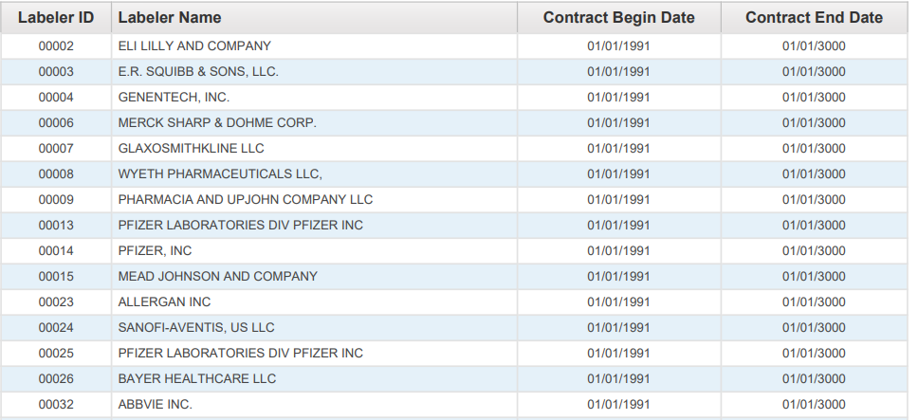

For a claim with drug HCPCS/CPT codes to be eligible for payment, the detail date of service must be prior to the *NDC termination date*. The NDC termination date represents the shelf-life expiration date of the last batch produced, as supplied on the Centers for Medicare and Medicaid Services (CMS) quarterly update. The date is supplied to CMS by the drug manufacturer/distributor.

Arkansas Medicaid will deny claim details with drug HCPCS/CPT codes with a detail date of service equal to or greater than the NDC termination date.

When completing a Medicaid claim for administering a drug, indicate the HIPAA standard 11-digit NDC with no dashes or spaces. The 11-digit NDC is comprised of three (3) segments or codes: a 5-digit labeler code, a 4-digit product code, and a 2-digit package code. The 10-digit NDC assigned by the FDA printed on the drug package must be changed to the 11-digit format by inserting a leading zero (0) in one (1) of the three (3) segments. Below are examples of the FDA assigned NDC on a package changed to the appropriate 11-digit HIPAA standard format. Diagram 2 displays the labeler code as five (5) digits with leading zeros; the product code as four (4) digits with leading zeros; the package code as two (2) digits without leading zeros, using the “5-4-2” format.

*Diagram 2*

|  |  |  |
| --- | --- | --- |
| **00123** | **0456** | **78** |
| **LABELER CODE**  **(5 digits)** | **PRODUCT CODE**  **(4 digits)** | **PACKAGE CODE**  **(2 digits)** |

**NDCs submitted in any configuration other than the 11-digit format will be rejected/denied.** *NDCs billed to Medicaid for payment must use the 11-digit format without dashes or spaces between the numbers.*

See Diagram 3 for sample NDCs as they might appear on drug packaging and the corresponding format which should be used for billing Arkansas Medicaid:

*Diagram 3*

|  |  |
| --- | --- |
| **10-digit FDA NDC on PACKAGE** | **Required 11-digit NDC**  **(5-4-2) Billing Format** |
| 12345  6789  1 | 123456789**0**1 |
| 1111-2222-33 | **0**1111222233 |
| 01111  456  71 | 01111**0**45671 |

**B. Drug Procedure Code (HCPCS/CPT) to NDC Relationship and Billing Principles**

HCPCS/CPT codes and any modifiers will continue to be billed per the policy for each procedure code. However, the NDC and NDC quantity of the administered drug is now also required for correct billing of drug HCPC/CPT codes. To maintain the integrity of the drug rebate program, it is important that the specific NDC from the package used at the time of the procedure be recorded for billing. HCPCS/CPT codes submitted using invalid NDCs or NDCs that were unavailable on the date of service will be rejected/denied. We encourage you to enlist the cooperation of all staff members involved in drug administration to assure collection or notation of the NDC from the actual package used. It is not recommended that billing of NDCs be based on a reference list, as NDCs vary from one (1) labeler to another, from one (1) package size to another, and from one (1) time period to another.

Exception: There is no requirement for an NDC when billing for vaccines, radiopharmaceuticals, and allergen immunotherapy.

**I. Claims Filing**

The HCPCS/CPT codes billing units and the NDC quantity do not always have a one-to-one relationship.

Example 1: The HCPCS/CPT code may specify up to 75 mg of the drug whereas the NDC quantity is typically billed in units, milliliters or grams. If the patient is provided 2 oral tablets, one at 25 mg and one at 50 mg, the HCPCS/CPT code unit would be 1 (1 total of 75 mg) in the example whereas the NDC quantity would be 1 each (1 unit of the 25 mg tablet and 1 unit of the 50 mg tablet). See Diagram 4.

*Diagram 4*

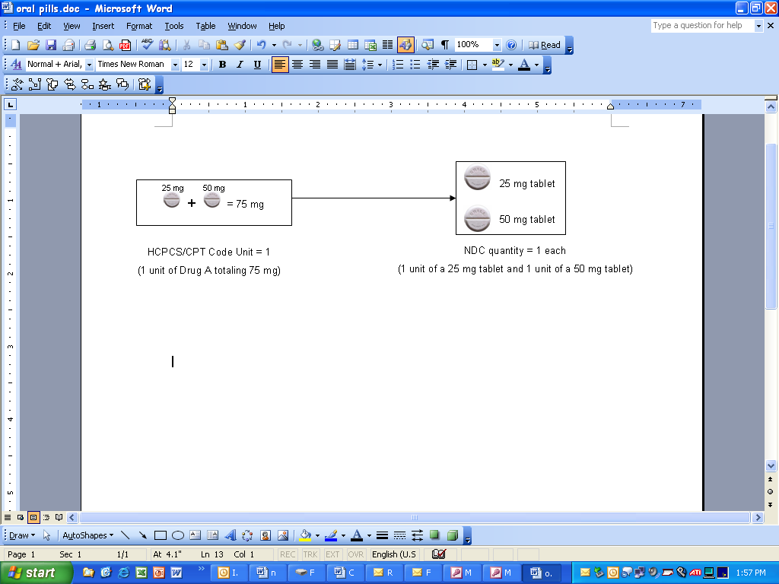

Example 2: If the drug in the example is an injection of 5 ml (or cc) of a product that was 50 mg per 10 ml of a 10 ml single-use vial, the HCPCS/CPT code unit would be 1 (1 unit of 25 mg) whereas the NDC quantity would be 5 (5 ml). In this example, 5 ml or 25 mg would be documented as wasted. See Diagram 5. For billing wastage, see bullets A (Electronic Claims Filing) and B (Paper Claims Filing) below.

*Diagram 5*

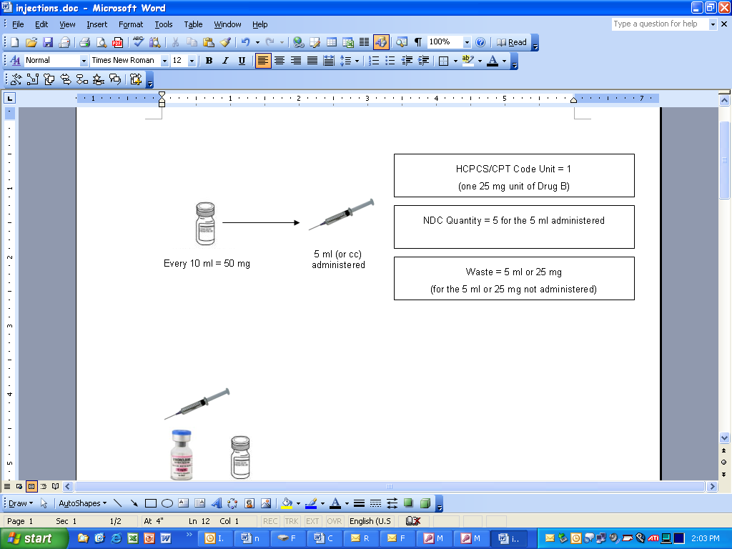

**A. Electronic Claims Filing – 837P (Professional) and 837I (Outpatient)**

Providers are instructed to bill as follows:

* 1 NDC for a procedure – 1st/only detail shall be billed with no modifier
* 2 NDCs for same procedure – 1st detail shall be billed with a KP and 2nd gets billed with a KQ modifier
* 3 NDCs for same procedure – 1st detail shall be billed with a KP and 2nd & 3rd detail get billed with a KQ modifier
* 4 or more NDCs for same procedure – submit via paper claim
* Wastage of each NDC shall be billed on a separate line with a JW modifier.

NOTE: The NDCs listed above are not the same (unless with a JW modifier). Same NDCs shall be billed on a single line with appropriate units.

**NOTE: CMS definitions of modifiers:**

* KP = First drug of a multiple drug unit dose formulation
* KQ = Second or subsequent drug of a multiple drug unit dose formulation
* JW = Drug wastage

**B. Paper Claims Filing – CMS-1500 and CMS-1450 (UB-04)**

Arkansas Medicaid will require providers billing drug HCPCS/CPT codes including covered unlisted drug procedure codes to use the required NDC format.

See Diagram 6 for CMS-1500 and Diagram 7 for CMS-1450 (UB-04).

**CMS-1500**

For professional claims, CMS-1500, list the qualifier of “N4”, the 11-digit NDC, the unit of measure qualifier (F2 - International Unit; GR - Gram; ML - Milliliter; UN - Unit), and the number of units of the actual NDC administered in the shaded area above detail field 24A, spaced and arranged exactly as in Diagram 6.

Providers are instructed to bill as follows:

* 1 NDC for a procedure – 1st/only detail shall be billed with no modifier
* 2 NDCs for same procedure – 1st detail shall be billed with a KP and 2nd gets billed with a KQ modifier
* 3 NDCs for same procedure – 1st detail shall be billed with a KP and 2nd & 3rd detail get billed with a KQ modifier
* 4 or more NDCs for same procedure – 1st detail shall be billed with a KP and 2nd and subsequent details shall be billed with a KQ modifier
* Wastage of each NDC shall be billed on a separate line with a JW modifier.

**NOTE: CMS definitions of modifiers:**

* KP = First drug of a multiple drug unit dose formulation
* KQ = Second or subsequent drug of a multiple drug unit dose formulation
* JW = Drug wastage

*Diagram 6*

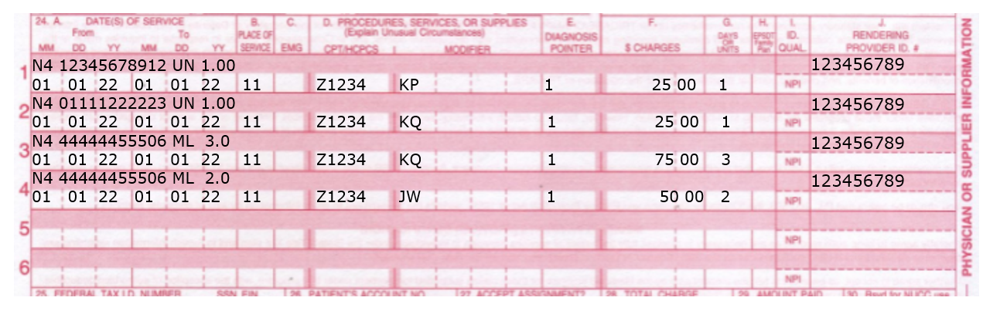

**CMS-1450 (UB-04)**

For institutional outpatient claims on the CMS-1450 (UB-04), use the locator field 43 (Description) to list the qualifier of “N4”, the 11-digit NDC, the unit of measure qualifier (F2 - International Unit; GR - Gram; ML - Milliliter; UN - Unit), and number of units of the actual NDC administered, spaced, and arranged exactly as in Diagram 7.

Providers are instructed to bill as follows:

* 1 NDC for a procedure – 1st/only detail shall be billed with no modifier
* 2 NDCs for same procedure – 1st detail shall be billed with a KP and 2nd gets billed with a KQ modifier
* 3 NDCs for same procedure – 1st detail shall be billed with a KP and 2nd & 3rd detail get billed with a KQ modifier
* 4 or more NDCs for same procedure – 1st detail shall be billed with a KP and 2nd and subsequent details shall be billed with a KQ modifier
* Wastage of each NDC shall be billed on a separate line with a JW modifier.

**NOTE: CMS definitions of modifiers:**

* KP = First drug of a multiple drug unit dose formulation
* KQ = Second or subsequent drug of a multiple drug unit dose formulation
* JW = Drug wastage

*Diagram 7*

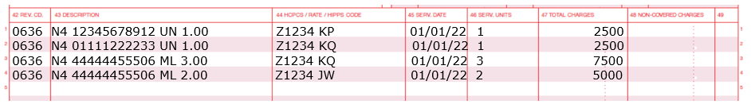

**II. Adjustments**

Paper adjustments for paid claims filed with NDC numbers will not be accepted. Any original claim will have to be voided and a replacement claim will need to be filed. Providers have the option of adjusting a paper or electronic claim electronically.

**III. Record Retention**

Each provider must retain all records for five (5) years from the date of service or until all audit questions, disputes or review issues, appeal hearings, investigations, or administrative/judicial litigation to which the records may relate are concluded, whichever period is longer. At times, a manufacturer may question the invoiced amount, which results in a drug rebate dispute. If this occurs, you may be contacted requesting a copy of your office records to include NDC invoices showing the purchase of drugs and documentation showing what drug (name, strength, and amount) was administered and on what date, to the beneficiary in question.